**MENU APP**

**Aim:**

To design and develop a mobile application for a restaurant that showcases menu options, user profile details, and a personalized user experience.

**Procedure:**

1. Start a new file and set the frame size to 360x640 (small Android screen).
2. Design the welcome screen with the app logo, tagline, and a "Get Started" button.
3. Create a homepage layout with a search bar, featured deals, and categories like "Discover new tastes."
4. Use image placeholders for food categories and add relevant labels/icons.
5. Design the menu section with items, prices, ratings, and an "Add to Cart" button.
6. Create a user profile page with a circular profile image, statistics (transactions/reviews), and a "Favorites" section.
7. Maintain consistent design, typography, and colors for a seamless user experience.
8. Test responsiveness and ensure proper alignment across all components.

**Diagram:**

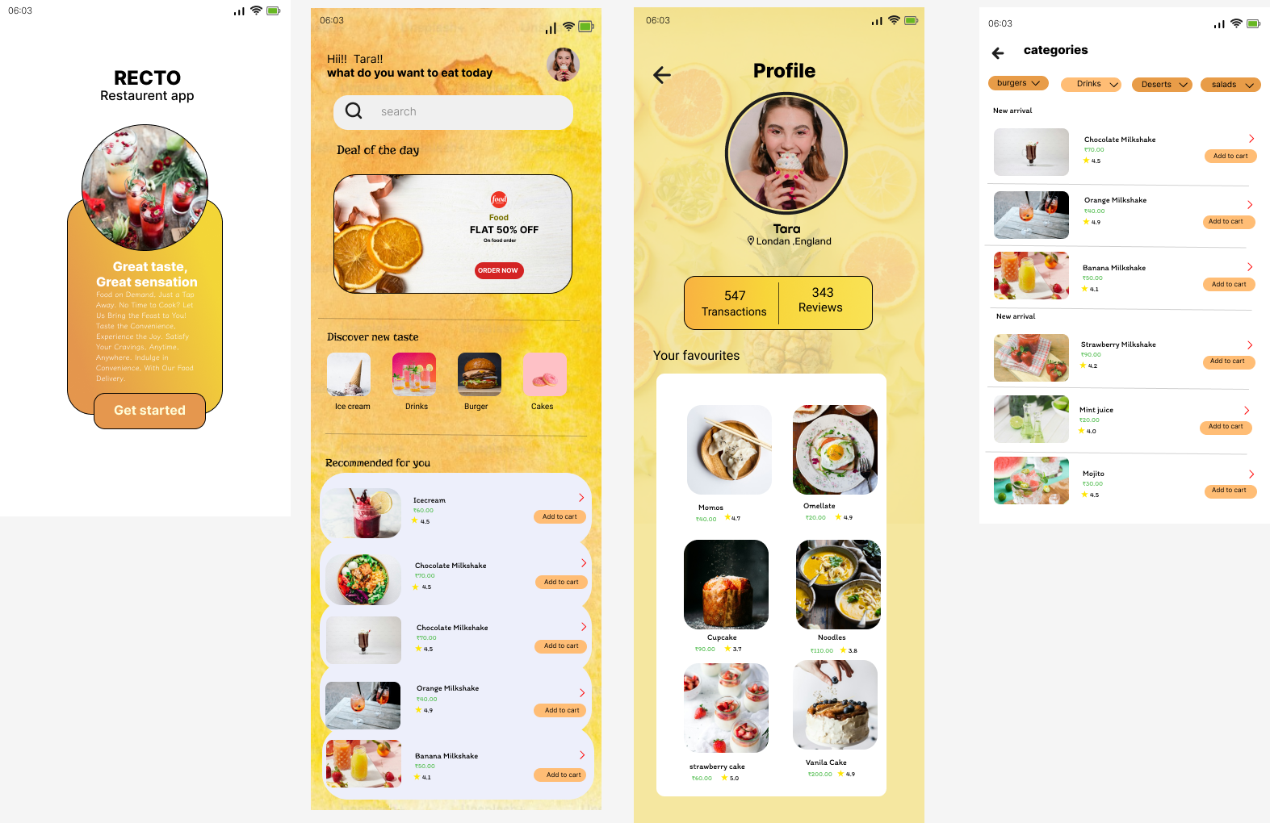

**Result:**

The mobile application for a restaurant is successfully designed with user-friendly navigation and appealing visuals.